Seferis, George (1900-1971)
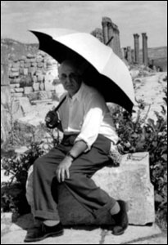
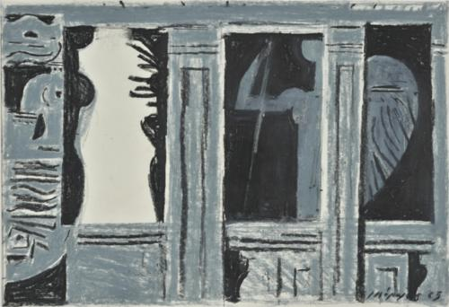
Widely recognised as the main representative of the GREEK MODERNISM associated with the ‘Thirties’ Generation’, George Seferis was born Georgios Seferiades (Γεώργιος Σεφεριάδης) in Urla, near Smyrna (now Izmir, Turkey) in 1900 and died on 20 September 1971 in Athens, Greece. His funeral became a symbolic act against the military junta (1967-74) with crowds following his coffin through Athens singing his poem ‘Denial’ (‘Αρνηση’) as set to music by Mikis Theodorakis. The song was banned by the regime at the time. The first Greek to receive a Nobel Prize in 1963, Seferis travelled widely and had a successful diplomatic career working for the Greek Ministry of Foreign Affairs. It was on Christmas Eve 1931, while Seferis was posted in London, that he discovered T. S. ELIOT’s ‘Marina’ and The Waste Land in which he discerned a resurrection of the dramatic tradition. The literary friendships he forged from this period onwards led to the translation into English of the collection The King of Asine and Other Poems by Nanos Valaoritis, Lawrence Durrell, Bernard Spencer, and George Katsimablis published in 1948 by John Lehmann’s publishing house. His personal and political journals covering the period from the 1920s until the 1960s are important documents preserving a view of Greece’s historical and cultural development from the perspective of a twentieth century traveller.
The destruction of Smyrna in 1922, in the climax of a war that brought about the compulsory exchange of populations between Greece and Turkey in 1923, left a long-lasting mark on the writing of his generation whose responsibility it was, as Seferis noted in his Nobel Lecture, to create a new ‘moral orientation after the exodus of one and a half million people from Asia Minor’ and their ‘reflux’ to the Greek mainland. The clash between European and Greek Hellenism, as Seferis termed the search for the unique Greek elements that would in their turn ‘ferment’ modern Europe (a quest voiced by George Theotokas in his 1929 essay ‘Free Spirit’), was part of an exploration by the writers of the Thirties of the identity of modern Greece.
Seferis started his career as a translator (his first published work was a rendition of PAUL VALÉRY’s Monsieur Teste in 1928) with the poetry collection Turning Point (‘Στροφή’) appearing in 1931, The Cistern (‘Η Στέρνα’) in 1932, Mythistorema, a seminal Modernist text in 24 sections of free verse, following shortly after in 1935, and the first edition of his translation of T.S. ELIOT’s The Waste Land (1922) in 1936. The struggle for a living language, Seferis noted, which the GREEK MODERNISTS inherited as the fraught Greek language question abated in the 1930s, ‘went beyond literature and was characterized by the will to challenge every aspect of the present.’ Significantly, when translating The Waste Land into Greek in the early 1930s, Seferis found ‘spiritual cross-breedings’ at the core of influences amongst nations, while he noted that the modern craft of speech was initiated in British letters by two Irishmen and two Americans, namely, W.B. YEATS, JAMES JOYCE, EZRA POUND and T.S. ELIOT. The openness of Greek Letters to a world of influences from abroad was one of the prerequisites for the renewal Seferis worked to bring to literature of his time.
Seferis maps a Greek landscape filled with ruins of the past (‘I woke with this marble head in my hands; / it exhausts my elbows and I don’t know where to put it down’, Mythistorema, trans. Keeley and Sherrard) and the feeling that ‘men of inconstancy, of wanderings and of wars [...] always move among the same monsters and the same longings’ (‘A Letter on “Thrush”’, 1949). Two additional examples of his style are to be found in his poems ‘Erotikos Logos’ (‘Ερωτικός Λόγος’, 1930) and ‘Thrush’ (‘Κίχλη’, 1946). His language and ‘mythical method’ draw from the Cretan literature of the sixteenth and seventeenth centuries, folk tradition, Homer and the Greek tragedians. With a rich body of work, including poetry, essays, letters, translations, journals and an early novel, Seferis was trying to problematize, in BAUDELAIRE’s terms, the present’s ‘essential quality of being the present’ by allowing legendary figures to move ‘anachronistically onto the contemporary stage that the poet has set before our eyes’ (Edmund Keeley and Philip Sherrard, ‘Foreword’ to Collected Poems, 1995, xiv).

List of Key Works
Seferis, George (1995) Collected Poems, trans and ed. Edmund Keeley and Philip Sherrard, London: Anvil Press Poetry.
Seferis, George (1992) On the Greek Style: Selected Essays in Poetry and Hellenism, trans. Rex Warner and Th.D. Frangopoulos, Greece: Denise Harvey.
Seferis, George (1975) Days of 1945-1951: A Poet's Journal, trans. A. Anagnostopoulos, Cambridge, Mass.: Harvard University Press.
Eliot, T.S. (1973) Η Έρημη Χώρα (The Waste Land, 1936), 5th edn, trans. George Seferis, Athens: Ikaros.
Seferis, George (1969) Three Secret Poems, trans Walter Kaiser, Cambridge, Mass.: Harvard University Press.
Seferis, George (2007) A Levant Journal, trans. Roderick Beaton, Jerusalem: Ibis Editions.
Seferis, George (2007) Six Nights on the Acropolis: A Novel, trans Susan Matthias, River Vale, N. J.: Cosmos Publishing.

References and Further Reading
Beaton, Roderick (2003) George Seferis: Waiting for the Angel, A Biography, New Haven: Yale University Press.
Keeley, Edmund (1970), ‘George Seferis: The Art of Poetry No 13’, The Paris Review, 50 (Fall),
http://www.theparisreview.org/interviews/4112/the-art-of-poetry-no-13-george-seferis
Seferis, George (1963), Nobel Prize Lecture, http://www.nobelprize.org/nobel_prizes/literature/laureates/1963/seferis-lecture.html
Theotokas, George (1986) ‘Free Spirit’ (1929), tr. Soterios G. Stavrou, Modern Greek Studies Yearbook 2, 153-200.
Tziovas, D. (ed.) (1997) Greek Modernism and Beyond: Essays in Honor of Peter Bien, Lanham, Maryland: Rowman and Littlefield Publishers, Inc.

Konstantina Georganta

